**BIG DATA AND HADOOP**

**Project Report**

*Submitted by*

**RUTANSHU JHAVERI 15BCE2016**

**VENIKA ANAND 15BCE0998**

**UJJWAL KHANNA 15BCE0658**

**PAUL MATHAI 15BCE0981**

**RAHUL RAGHUNADHAN 15BCE0987**

Course Code: **CSE4001**

Course Title: **Parallel and Distributed Computing**

Under the guidance of

**Prof. MANOOV R  
Associate Professor (Senior), SCSE**

**VIT University, Vellore-632014**



**Department of ….**

**School of Computer Science**

**And Engineering**

**NOVEMBER 2017**

**TABLE OF CONTENTS**

|  |  |  |
| --- | --- | --- |
| **S NO.** | **CONTENT** | **PAGE NO.** |
| 1. | **ABSTRACT** | 3. |
| 2. | **INTRODUCTION** | 4. |
| 3. | **PROJECT BACKGROUND** | 5. |
| 4. | **HADOOP 1.X** | 10. |
| 5. | **IMPLEMENTATION EX** | 12. |
| 6. | **HADOOP 2.X** | 17. |
| 7. | **IMPLEMENTATION EX** | 22. |
| 8. | **HDFS FILE READ WORKFLOW** | 24. |
| 9. | **ELT and ETL** | 25. |
| 10. | **DIFFERENT VENDORS** | 27. |
| 11. | **DATA PIPELINE DESIGN - IMPLEMENTATION** | 29. |

**ABSTRACT**

The term ‘Big Data’ defines innovative techniques and expertise to capture, collect, allocate, manage and analyze petabyte- or larger-sized datasets with high-speed and entirely dissimilar structures. Big Data is structured, unstructured or semi-structured, leading to incapability of typical knowledge management ways. Data is generated from varied completely different sources and may arrive within the system at varied rates. So as to process these massive amounts of information in a cheap and economical means, parallelism is employed. Big Data could be a data whose scale, diversity, and quality need new design, techniques, algorithms, and analytics to manage it and extract price and hidden data from it. Hadoop is that the core platform for structuring Big Data, and solves the matter of constructing it helpful for analytics functions. Hadoop is Associate in nursing open supply package project that permits the distributed process of Big Datasets across clusters of artifact servers. It’s designed to rescale from one server to thousands of machines, with an awfully high degree of fault tolerance.

**INTRODUCTION**

**Big Data** could be a term that refers to information sets or mixtures of information sets whose size (volume), complexness (variability), and rate of growth (velocity) build them tough to be captured, managed, processed or analyzed by standard technologies and tools, like relative databases and desktop statistics or mental image packages, among the time necessary to form them helpful, whereas the dimensions accustomed confirm whether or not a selected information set is taken into account huge information isn't firmly outlined and continues to vary over time, most analysts and practitioners presently sit down with information sets from 30-50 terabytes to multiple petabytes as Big Data. It is rotten into 3 layers, as well as Infrastructure Layer, Computing Layer, and Application Layer from prime to bottom.

**3 Vs of Big Data**

**Volume of data**: Volume denotes to amount of data. Volume of information deposited in enterprise depositories have grown from megabytes and gigabytes to petabytes.

**Variety of data**: Different types of data and sources of data. Information diversity blasted from structured and legacy evidence kept in enterprise repositories to unstructured, semi structured, audio, video, XML etc.

**Velocity of data**: Velocity denotes to the speed of data processing. For time-sensitive proceedings such as gathering fraud, big data must be used as it streams into your enterprise in order to develop its value.

**Hadoop**

Hadoop is a Programming framework used to support the handling of vast data sets in a distributed computing environment. Hadoop was established by Google’s MapReduce that is a software framework where an application breakdown into various parts. The Current Appache Hadoop ecosystem comprises of the Hadoop Kernel, MapReduce, HDFS & numbers of several components for eg. Apache Hive, Base and Zookeeper. HDFS and MapReduce are explained in following points.

**PROJECT BACKGROUND**

**HADOOP ECOSYSTEM**

The Hadoop system includes each official Apache open supply comes and a good vary of business tools and solutions. a number of the known open supply examples embrace Spark, Hive, Pig, Oozie and Sqoop. Industrial Hadoop offerings square measure even additional various and embrace platforms and prepacked distributions from vendors like Cloudera, Hortonworks, and MapR, and a range of tools for specific Hadoop development, production, and maintenance tasks.

Most of the solutions offered within the Hadoop system square measure meant to supplement one or 2 of Hadoop’s four core components (HDFS, MapReduce, YARN, and Common). However, the commercially offered framework solutions give additional comprehensive practicality. The sections below give look into a number of the more distinguished elements of the Hadoop system, beginning with the Apache comes.

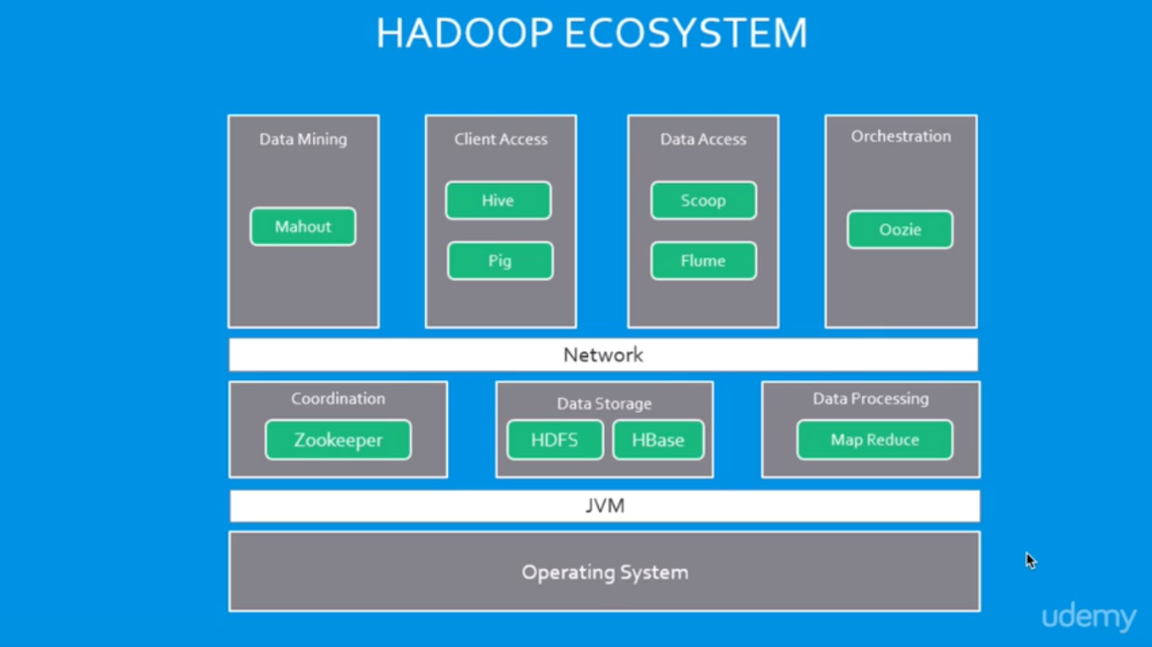

## **Apache open source Hadoop ecosystem elements**

#### The Apache Hadoop project actively supports multiple comes supposed to increase Hadoop’s capabilities and create it easier to use. There square measure many top-ranking comes to form development tools likewise as for managing Hadoop knowledge flow and process. Several industrial third-party solutions rest on the technologies developed inside the Apache Hadoop system.

#### Spark, Pig, and Hive square measure 3 of the known Apache Hadoop comes. Every employed to form applications to method Hadoop knowledge. whereas there square measure plenty of articles and discussions regarding whether or not Spark, Hive or Pig is healthier, in follow several organizations don't solely use one one as a result of every is optimized for specific functions.

#### **Spark**

Spark is each a programming model and a computing model. It provides a entry to in-memory computing for Hadoop, that may be a huge reason for its quality and wide adoption. Spark provides another to MapReduce that permits workloads to execute in memory, rather than on disk. Spark accesses information from HDFS however bypasses the MapReduce process framework, and therefore eliminates the resource-intensive disk operations that MapReduce needs. By exploitation in-memory computing, Spark workloads usually run between ten and one hundred times quicker compared to disk execution.

Spark may be used severally of Hadoop. However, it's used most typically with Hadoop as another to MapReduce for processing. Spark will simply exist with MapReduce and with different scheme elements that perform different tasks.

Spark is additionally standard as a result of it supports SQL, that helps overcome a defect in core Hadoop technology. The Spark programming setting works interactively with Scala, Python, and R shells. it's been used for information extract/transform/load (ETL) operations, stream process, machine learning development and with the Apache GraphX API for graph computation and show. Spark will run on a range of Hadoop and non-Hadoop clusters, as well as Amazon S3.

#### **Hive**

Hive is information deposition software system that addresses however information is structured and queried in distributed Hadoop clusters. Hive is additionally a preferred development surroundings that's wont to write queries for information within the Hadoop surroundings. It provides tools for ETL operations and brings some SQL-like capabilities to the surroundings. Hive could be a declarative language that's wont to develop applications for the Hadoop surroundings, but it doesn't support time period queries.

* HCatalog – Helps processing tools scan and write information on the grid. It supports MapReduce and Pig.
* WebHCat – allows you to use associate degree HTTP/REST interface to run MapReduce, Yarn, Pig, and Hive jobs.
* HiveQL – Hive’s source language meant as some way for SQL developers to simply add Hadoop. it's like SQL and helps each structure and question information in distributed Hadoop

Hive also allows MapReduce-compatible mapping and reduction software to perform more sophisticated functions. However, Hive does not permit row-level modernizes or maintenance for real-time queries, and it is not intended for OLTP workloads. Many consider Hive to be much more actual for handling structured data than unstructured data, for which Pig is considered beneficial.

**Pig**

Pig may be a procedural language for developing data processing applications for giant knowledge sets within the Hadoop surroundings. Pig is another to Java programming for MapReduce, and mechanically generates MapReduce functions. Pig includes Pig Latin, that may be a scripting language. Pig interprets Pig Latin scripts into MapReduce, which might then run on YARN and method knowledge within the HDFS cluster. Pig is fashionable as a result of it automates a number of the quality in MapReduce development.

#### Pig is often used for complicated use cases that need multiple knowledge operations. it's a lot of of a process language than a question language. Pig helps develop applications that mixture and type knowledge and supports multiple inputs and exports. it's extremely customizable, as a result of users will write their own functions victimisation their most well-liked scripting language. Ruby, Python and even Java square measure all supported. Thus, Pig has been a preferred possibility for developers that square measure aware of those languages however not with MapReduce. However, SQL developers might realize Hive easier to be told.

**HBase**

It absolutely was designed to store structured information in tables that would have billions of rows and countless columns. it's been deployed to power historical searches through giant information sets, particularly once the specified information is contained at intervals an oversized quantity of unimportant or orthogonal information (also referred to as thin information sets). it's additionally associate degree underlying technology behind many giant electronic communication applications, as well as Facebook’s.

HBase isn't a on-line database and wasn’t designed to support transactional and different period applications. it's accessible through a Java API and has ODBC and JDBC drivers. HBase doesn't support SQL queries, but there area unit many SQL support tools out there from the Apache project and from code vendors. as an example, Hive may be wont to run SQL-like queries in HBase.

**Oozie**

Oozie is that the work flow computer hardware that was developed as a part of the Apache Hadoop project. It manages however workflows begin and execute, and additionally controls the execution path. Oozie may be a server-based Java internet application that uses work flow definitions written in hPDL, that is associate degree XML method Definition Language like JBOSS JBPM jPDL. Oozie solely supports specific work flow varieties, therefore different work schedulers area unit unremarkably used rather than or additionally to Oozie in Hadoop environments.

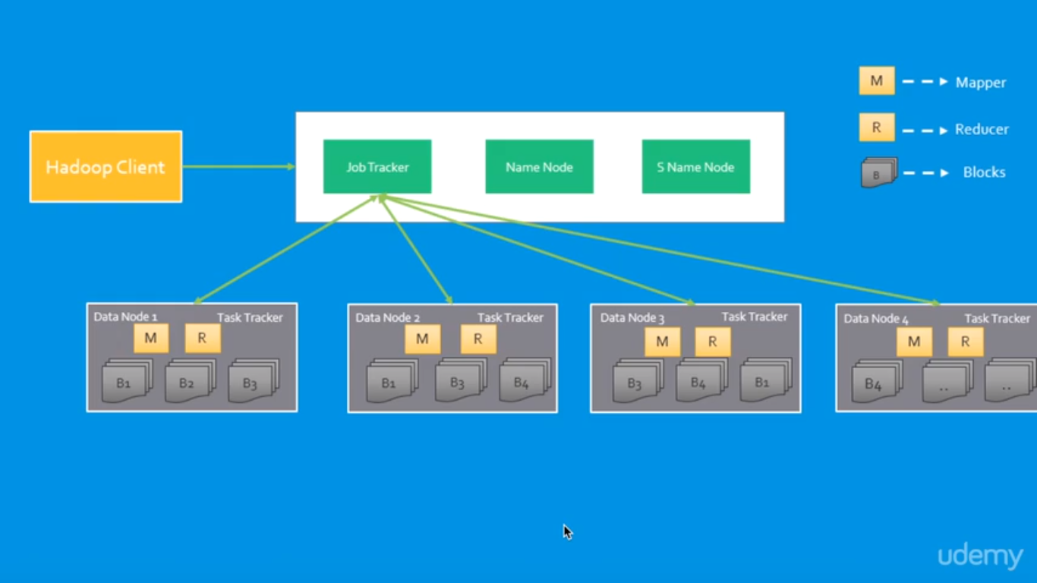

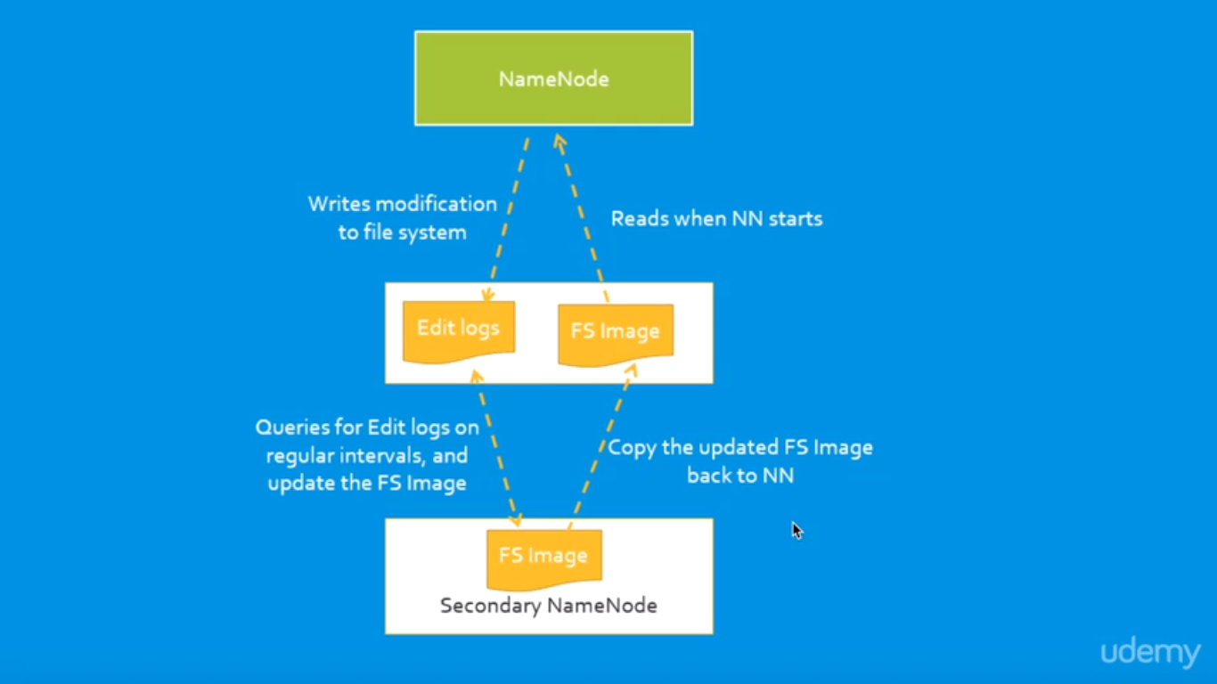

**HADOOP 1.X**

* Node limitations(supports up to 4,000 node/cluster)
* Job tracker bottleneck
* Only has one NameNode for managing HDFS
* Map and Reduce slots are static
* Only job to run is MapReduce

### **Hadoop 1.x Architecture**

### Apache Hadoop one.x or earlier versions area unit exploitation the subsequent Hadoop design. It is a Hadoop one.x High-level design. We are going to discuss in-detailed Low-level design in returning sections.

### Hadoop Common Module could be a Hadoop Base API (A Jar file) for all Hadoop elements. All different elements works on high of this module.

### HDFS stands for Hadoop Distributed filing system. It’s additionally understand as HDFS V1 because it is a component of Hadoop one.x. It’s used as a Distributed Storage System in Hadoop design.

* MapReduce could be a execution or Distributed processing Module. It’s designed by following Google’s MapReduce algorithmic program. It’s additionally understand as “MR V1” or “Classic MapReduce” because it is a component of Hadoop one.x. Remaining all Hadoop scheme elements work on high of those 2 major components: HDFS and MapReduce. We are going to discuss all Hadoop scheme elements in-detail in my returning posts.

[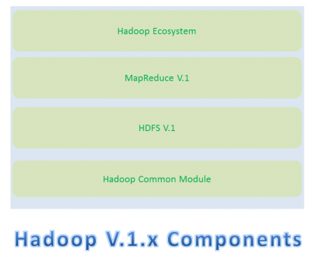](https://cdn.journaldev.com/wp-content/uploads/2015/08/hadoop1.x-components.png)

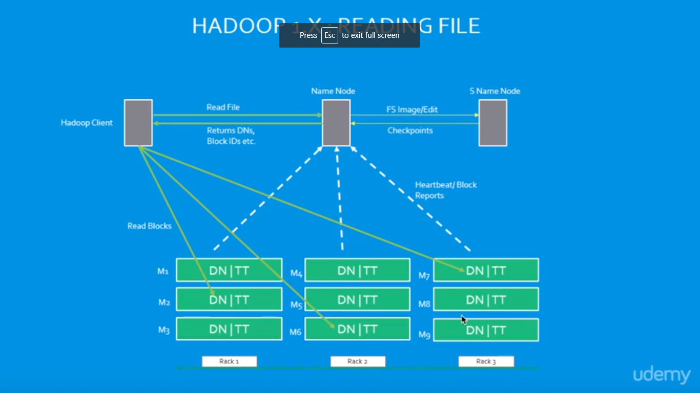

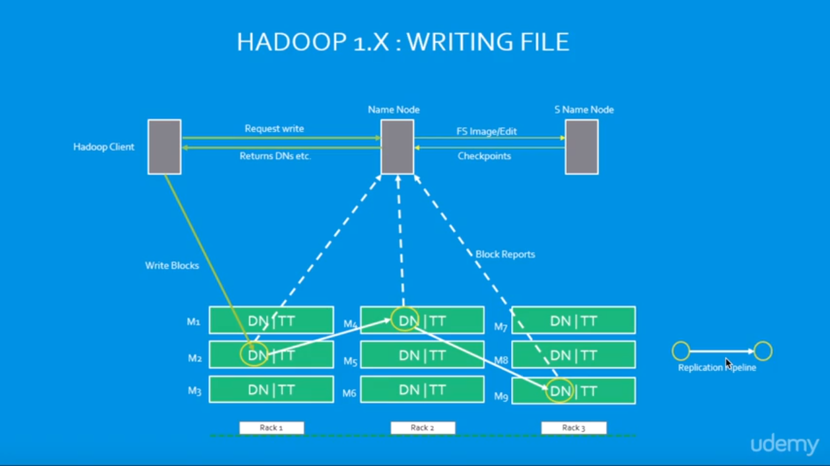

### **Hadoop 1.x - Major Components**

### Hadoop 1.x Major parts parts are: HDFS and MapReduce. They’re additionally apprehend as “Two Pillars” of Hadoop one.x.

### **HDFS:**

### HDFS may be a Hadoop Distributed FileSystem, wherever our BigData is hold on victimisation goods Hardware. it's designed to figure with giant DataSets with default block size is 64MB (We will amendment it as per our Project requirements).

### HDFS element is once more divided into 2 sub-components:

### Name Node

### Name Node is placed in Master Node. It accustomed store Meta information regarding information Nodes like “How several blocks area unit hold on in information Nodes, that information Nodes have information, Slave Node Details, information Nodes locations, timestamps etc” .

### Data Node

* Data Nodes area unit places in Slave Nodes. It’s accustomed store our Application Actual information. It stores information in information Slots of size 64MB by default.

[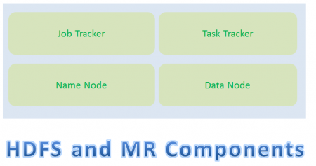](https://cdn.journaldev.com/wp-content/uploads/2015/08/hadoop1.x-hdfs-mr-components.png)

**MapReduce:**

MapReduce may be a Distributed processing or execution Programming Model. Like HDFS, MapReduce part additionally uses

* Commodity Hardware to method “High Volume of form of knowledge at High rate Rate” in a very reliable and fault-tolerant manner.
* MapReduce part is once more divided into 2 sub-components:
* Job hunter

Job hunter is employed to assign MapReduce Tasks to Task Trackers within the Cluster of Nodes. Occasionally, it reassigns same tasks to alternative Task Trackers as previous Task Trackers ar failing or closedown eventualities. Job hunter maintains all the Task Trackers standing like Up/running, Failed, Recovered etc.

* Task hunter
* Task hunter executes the Tasks that are assigned by Job hunter and sends the standing of these tasks to Job hunter.
* We can deliberate these four sub-component’s responsibilities and the way they move one another to perform a “Client Application Tasks” intimately in next section.
* How Hadoop one.x Major elements Works
* Hadoop 1.x elements follow this design to move one another and to figure parallel in a very dependable and fault-tolerant manner.

**Implementation Example:-**



Mapper and reducer shell scripts to count the words “hello” and “world”



**Giving permission to file of shell scripts**

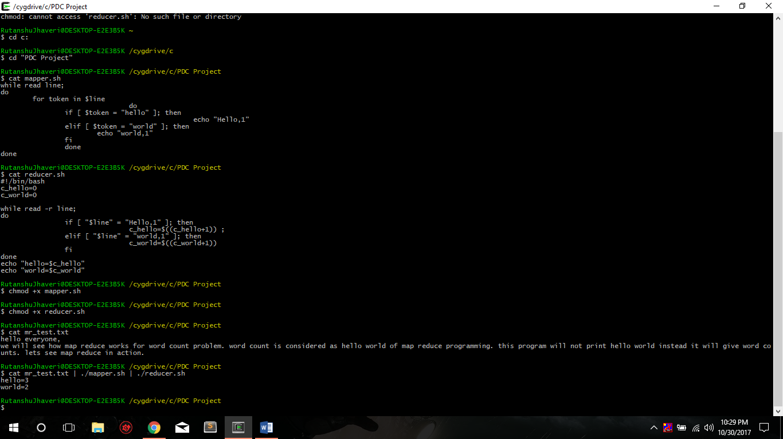

**Project is on Virtual Box**

We can show the code pig and hive files.

Therefore, there is no directory to show, The final project would be shown in video of Review 3.

* https://github.com/rutanshuj/PDCProject

**Hadoop 1.x - Components In-detail Architecture**

[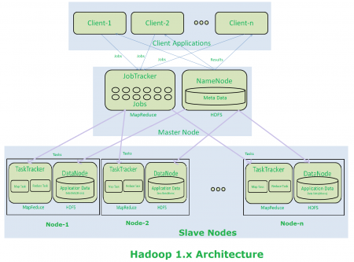](https://cdn.journaldev.com/wp-content/uploads/2015/08/hadoop2.x-components-architecture.png)

**Hadoop 1.x Architecture Description**

* Clients submit their work to Hadoop System.
* When Hadoop System receives a consumer Request, initial it's received by a Master Node.
* Master Node’s MapReduce half “Job Tracker” is in charge of receiving shopper Work and divides into manageable freelance Tasks and assign them to Task Trackers.
* Slave Node’s MapReduce half “Task Tracker” receives those Tasks from “Job Tracker” and perform those tasks by exploitation MapReduce components.
* Once all Task Trackers finished their job, Job hunter takes those results and combines them into effect.
* Finally Hadoop System will send that effect to the consumer.
* How Store and figure Operations add Hadoop
* All these Master Node and Slave Nodes square measure organized into a Network of clusters. each Cluster is over again divided into Racks. each rack contains a bunch of Nodes (Commodity Computer).
* When Hadoop system receives “Store” operation like storing large DataSets into HDFS, it stores that data into 3 altogether completely different Nodes (As we've got a bent to piece Replication issue = 3 by default). this whole data is not hold on in one single node. large record is split into manageable and purposeful Blocks and distributed into altogether completely different nodes with 3 copies.
* If Hadoop system receives any “Compute” operation, it's going to sit down with near-by nodes to retrieve those blocks of information. whereas Reading data or Computing if one or further nodes get failing, then it's going to automatically pick-up performing those tasks by approaching any near-by and on the market node.
* That’s why Hadoop system provides very on the market and fault tolerant Big Data Solutions.

**NOTE:-**

* Hadoop 1.x Architecture has lot of limitations and drawbacks. So that Hadoop Community has evaluated and redesigned this Architecture into Hadoop 2.x Architecture.
* Hadoop 2.x Architecture is completely different and resolved all Hadoop 1.x Architecture’s limitations and drawbacks.

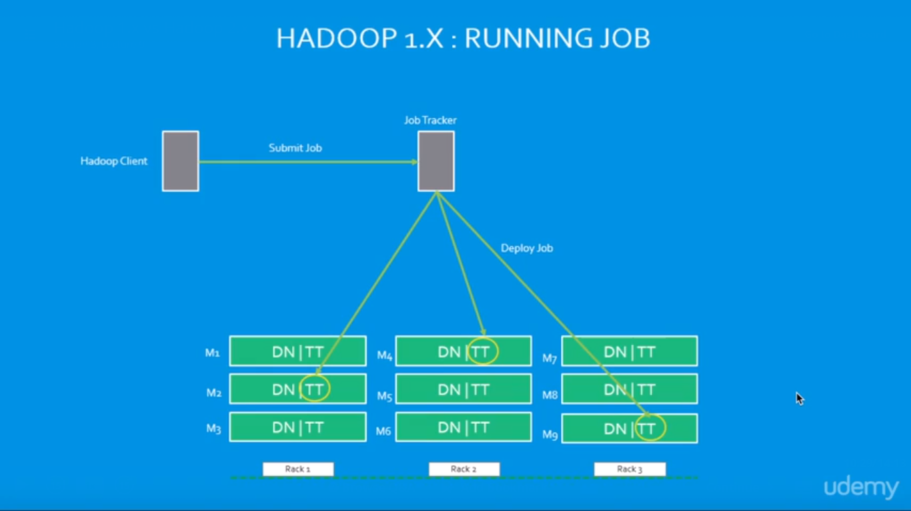

**HADOOP 2.X**

# **Introduction**

Apache Hadoop 2.0 signifies a generational shift in the construction of Apache Hadoop. With YARN, Apache Hadoop is recast as a significantly more powerful platform – one that takes Hadoop beyond merely batch applications to taking its position as a ‘data operating system’ where HDFS is the file system and YARN is the operating system.

YARN is a re-architecture of Hadoop that allows several applications to run on the similar platform. With YARN, applications run “in” Hadoop, instead of “on” Hadoop. The fundamental idea of YARN is to split up the two major responsibilities of the JobTracker and TaskTracker into separate entities

* Support up to to 10,000 node per cluster
* Supports multiple NameNodes for managing HDFS
* Introduction of YARN for efficient cluster utilization.
* MRv1 Backward and forward compatible
* Any apps can be integrated with Hadoop
* Beyond MapReduce

**Hadoop 2.x Architecture**

* Apache Hadoop two.x or later versions ar victimization the subsequent Hadoop design. it's a Hadoop two.x High-level design. we'll discuss in-detailed Low-level design in returning sections.
* Hadoop Common Module could be a Hadoop Base API (A Jar file) for all Hadoop parts. All alternative parts works on high of this module.
* HDFS stands for Hadoop Distributed filing system. it's additionally apprehend as HDFS V2 because it is a component of Hadoop two.x with some increased options. it's used as a Distributed Storage System in Hadoop design.
* YARN stands for yet one more Resource communicator. it's new part in Hadoop two.x design. it's additionally apprehend as “MR V2”.
* MapReduce could be a instruction execution or Distributed processing Module. it's additionally apprehend as “MR V1” because it is a component of Hadoop one.x with some updated options.
* Remaining all Hadoop scheme parts work on high of those 3 major components: HDFS, YARN and MapReduce. we'll discuss all Hadoop scheme parts in-detail in my returning posts.

When compared to Hadoop one.x, Hadoop 2.x design is intended fully completely different. It’s supplementary one new component: YARN and additionally updated HDFS and MapReduce component’s Responsibilities.When compared to Hadoop 1.x, Hadoop 2.x Architecture is designed completely different. It has added one new component: YARN and also updated HDFS and MapReduce component’s Responsibilities.

### **Hadoop 2.x Major Components**

[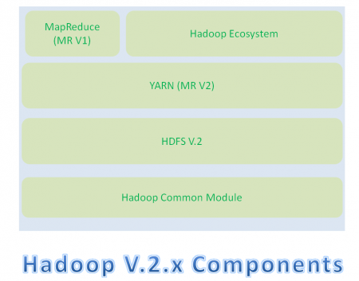](https://cdn.journaldev.com/wp-content/uploads/2015/08/hadoop2.x-components.png)Hadoop 2.x has the subsequent 3 Major Components:  
• HDFS  
• YARN  
• MapReduce  
These 3 also are called 3 Pillars of Hadoop a pair of. Here key element amendment is YARN. it's very game dynamicalelement in BigData Hadoop System.  
**How Hadoop a pair of.x Major elements Works**  
Hadoop 2.x elements follow this design to move one another and to figure parallel in an exceedingly reliable, extremely obtainable and fault-tolerant manner.

**Hadoop 2.x Components High-Level Architecture**

[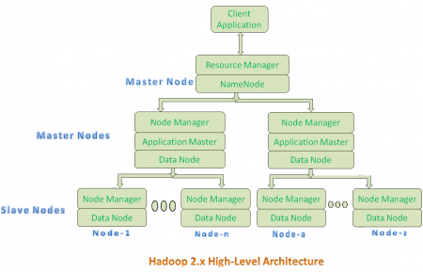](https://cdn.journaldev.com/wp-content/uploads/2015/08/hadoop2.x-highlevel-architecture.png)

All Master Nodes and Slave Nodes contains each MapReduce and HDFS elements.

* One Master Node has 2 components:
* Resource Manager(YARN or MapReduce v2)
* HDFS

HDFS element is additionally is aware of as NameNode. Its NameNode is employed to store Meta information. In Hadoop a pair of. X, some additional Nodes acts as Master Nodes as shown within the higher than diagram. Every this second level Master Node has three components:

* Node Manager
* Application Master
* Data Node

Each this second level Master Node {again|once additional} contains one or more Slave Nodes as shown within the higher than diagram.

These Slave Nodes have 2 components:

1. Node Manager
2. HDFS

HDFS element is additionally is aware of as information Node. Its information Node element is employed to store actual our application huge information. These nodes doesn't contain Application Master Element.

**Hadoop 2.x Components In-detail Architecture**

[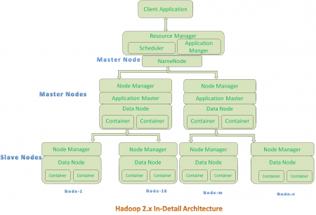](https://cdn.journaldev.com/wp-content/uploads/2015/08/hadoop2.x-indetail-architecture.png)

**Hadoop 2.x Architecture Description**

**Resource Manager:**

* Resource Manager could be a Per-Cluster Level part.
* Resource Manager is once more divided into 2 components:

1. Scheduler
2. Application Manager

* Resource Manager’s hardware is :

1. Responsible to schedule needed resources to Applications (that is Per-Application Master).
2. It will solely programming.
3. It will care regarding watching or following of these Applications.

**Application Master:**

* Application Master could be a per-application level part. it's accountable for:
* Managing allotted Application Life cycle.
* It interacts with each Resource Manager’s hardware and Node Manager
* It interacts with hardware to accumulate needed resources.
* It interacts with Node Manager to execute allotted tasks and monitor those task’s standing.

**Node Manager:**

* Node Manager could be a Per-Node Level part.

It is accountable for:

* Managing the life-cycle of the instrumentality.
* Monitoring every Container’s Resources utilization.

**Container:**

Each Master Node or Slave Node contains set of Containers. During this diagram, Main Node’s Name Node isn't showing the Containers. However, it conjointly contains a collection of Containers.

Container could be a portion of Memory in HDFS (Either Name Node or information Node).

In Hadoop two.x, instrumentality is comparable to information Slots in Hadoop one.x. We’ll see the foremost variations between these 2 Components: Slots Vs Containers in my returning posts.

**Implementation Example:-**



Mapper and reducer shell scripts to count the words “hello” and “world”



Giving permission to file of shell scripts



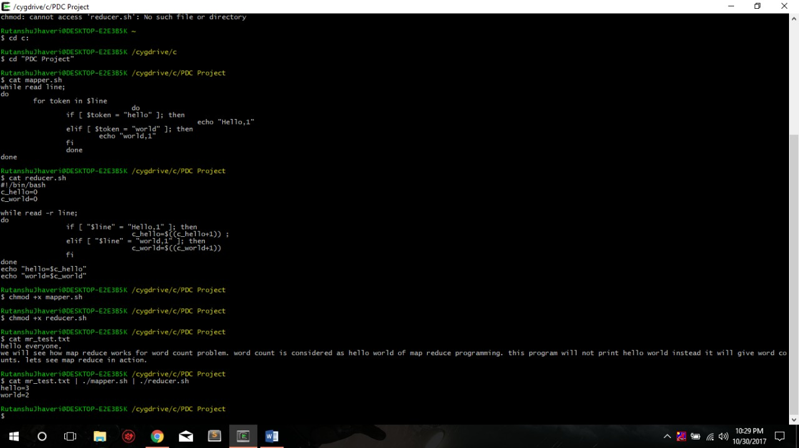

**Project is on Virtual Box**

We can show the code pig and hive files.

Therefore, there is no directory to show, The final project would be shown in video of Review 3.

https://github.com/rutanshuj/PDCProject

# **HDFS File Read Workflow**

Now let’s perceive complete finish to finish HDFS information scan operation. As shown within the higher than figure the info scan operation in HDFS is distributed, the shopper reads the info parallelly from datanodes, the steps by step clarification of information scan cycle is:

i) Shopper opens the file it desires to scan by vocation open () on the FileSystem object, that for HDFS is AN instance of DistributedFileSystem.

ii) DistributedFileSystem calls the namenode victimization RPC to work out the locations of the blocks for the primary few blocks within the file. for every block, the namenode returns the addresses of the datanodes that have a duplicate of that block and datanode square measure sorted in line with their proximity to the shopper.

iii) Distributed Filesystem returns a FSDataInputStream to the shopper for it to scan information from. FSDataInputStream, thus, wraps the DFSInputStream that manages the datanode and name node I/O. shopper calls read () on the stream. DFSInputStream that has keep the datanode addresses then connects to the nearest datanode for the primary block within the file.

iv) Information is streamed from the datanode back to the shopper, as a result shopper will decision read () repeatedly on the stream. Once the block ends, DFSInputStream can shut the association to the data node then finds the simplest data node for succeeding block.

v) If the DFSInputStream encounters a blunder whereas communication with a datanode, it'll attempt succeeding nearest one for that block. It’ll conjointly bear in mind datanodes that have failing so it doesn’t needlessly rehear them for later blocks. The DFSInputStream conjointly verifies checksums for the info transferred to that from the datanode. If it finds a corrupt block, it reports this to the namenode before theDFSInputStream makes an attempt to scan a duplicate of the block from another datanode.

vi) once the shopper has finished reading the info, it calls close() on the stre

# **ELT and ETL**

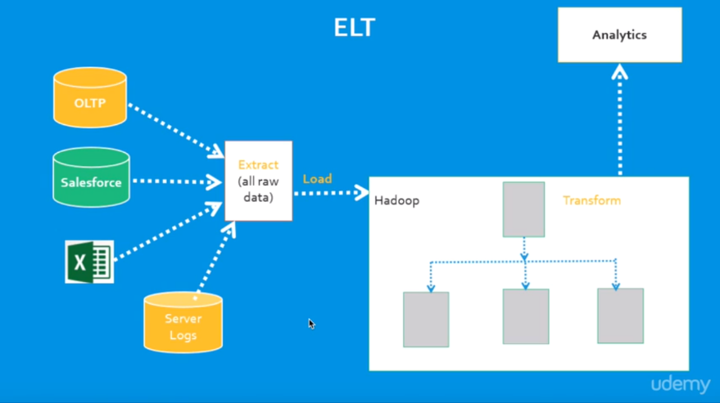These 2 definitions of ETL area unit what create ELT somewhat confusing? ELT may be a completely different means of staring at the tool approach to information movement. Rather than reworking the information before it’s written, ELT leverages the target system to try and do the transformation. The information is traced to the target so remodeled in situ.

ETL, on the opposite hand, is intended employing a pipeline approach. Whereas information is flowing from the supply to the target, a metamorphosis engine (something distinctive to the tool) takes care of any information changes.

Which is best depends on priorities. All things being equal, it’s higher to possess fewer moving elements. ELT has no transformation engine – the work is finished by the target system, which is already there and possibly being employed for alternative development work. On the opposite hand, the ETL approach will offer drastically higher performance in bound situations.

The coaching and development prices of ETL ought to be weighed against the requirement for higher performance. (Additionally, if you don’t have a target system powerful enough for ELT, ETL could also be additional economical.

The specifics of ELT development can vary counting on the platform. as an example, Hadoop clusters work by breaking a tangle into smaller chunks, then distributing those chunks across an oversized variety of machines for process.

The problem is solved quicker as a result of it’s being worn out parallel. this needs careful style to create certain that the act of rending the matter will be refrained from poignant the solution. Some issues will be simply split, others are going to be a lot of tougher.

ELT is a wonderful military science tool for loading a knowledge warehouse. It needs a strong system in situ because the target, however additional and additional warehouses area unit being designed with such systems in mind to fulfill ever-growing analytic wants. like any tool, knowing once to use it's a minimum of as vital as knowing the way to use it. Ironsides will offer strategic direction and/or technical support in information integration and management. Contact North American nation nowadays to debate that choices suit your surroundings best.

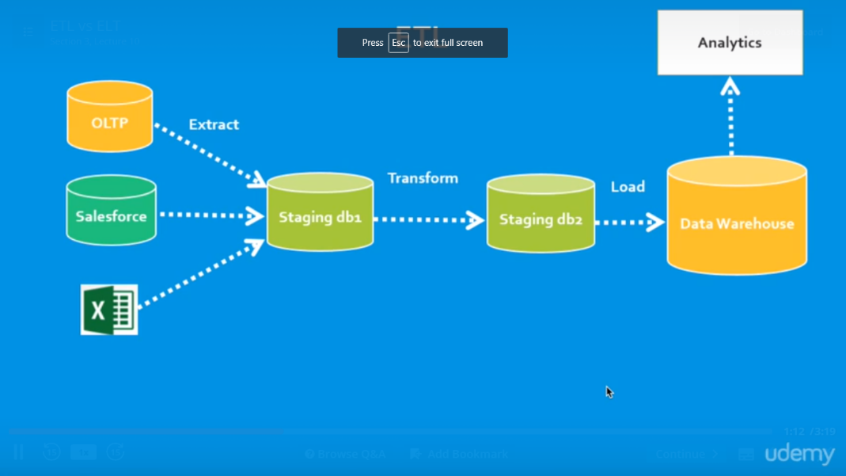

**Different Vendors:**

**Amazon Elastic MapReduce (EMR)**

It is Associate in Nursing Amazon internet Services (AWS) tool for giant processing and analysis. Amazon EMR offers the expandable low-configuration service as a neater different to running in-house cluster computing.

Amazon EMR is predicated on Apache Hadoop, a Java-based programming framework that supports the process of huge knowledge sets in a very distributed computing setting. MapReduce may be a package framework that permits developers to write down programs that method large amounts of unstructured knowledge in parallel across a distributed cluster of processors or complete computers. it had been developed at Google for categorization sites and replaced their original categorization algorithms and heuristics in 2004.

Amazon EMR processes huge knowledge across a Hadoop cluster of virtual servers on Amazon Elastic reckon Cloud (EC2) and Amazon straightforward Storage Service (S3). The elastic in EMR's name refers to its dynamic resizing ability, that permits it to build or cut back resource use betting on the demand at any given time.

**Cloud Era**

Cloudera opposition. may be a United States-based package company that has Apache Hadoop-based package, support and services, and coaching to business customers.

Cloudera's ASCII text file Apache Hadoop distribution, CDH (Cloudera Distribution together with Apache Hadoop), targets enterprise-class deployments of that technology. Cloudera says that quite five hundredth of its engineering output is given upstream to the assorted Apache-licensed open supply comes (Apache Hive, Apache Avro, Apache HBase, and then on) that mix to create the Hadoop platform. Cloudera is additionally a sponsor of the Apache package Foundation.

**IBM InfoSphere**

InfoSphere DataStage may be a powerful knowledge integration tool.

It was noninheritable by IBM in 2005 and has become a neighborhood of IBM info Server Platform. It uses a shopper/server style wherever jobs square measure created and administered via a Windows client against central repository on a server.

The IBM InfoSphere DataStage is capable of desegregation knowledge on demand across multiple and high volumes of information sources and target applications employing a high performance parallel framework. InfoSphere DataStage additionally facilitates extended information management and enterprise property. it's 3 levels of correspondence that are:

Pipeline correspondence, knowledge correspondence, part correspondence

**Teradata**

Teradata Corporation may be a supplier of database-related product and services. The corporate was fashioned in 1979 in Brentwood, California, as a collaboration between researchers at Caltech and Citibank's advanced technology cluster.[2] the corporate was no inheritable by NCR Corporation in 1991, Associate in Nursing later on spun-off once more as an freelance public company on October one, 2007.

The company produces a electronic database management system of a similar name, that it markets as an information warehouse. Teradata offers 3 main services to its customers: cloud and hardware-based knowledge repositing, business analytics, and consulting services.

the company launched Teradata everyplace, that permits users to submit queries against public and personal databases. The service uses massively data processing across each its physical knowledge warehouse and cloud storage, together with managed environments like Amazon internet Services, Microsoft Azure, VMware, and Teradata's Managed Cloud and IntelliFlex Teradata offers customers each hybrid cloud and multi-cloud storage.

**Hello world count Pig program**

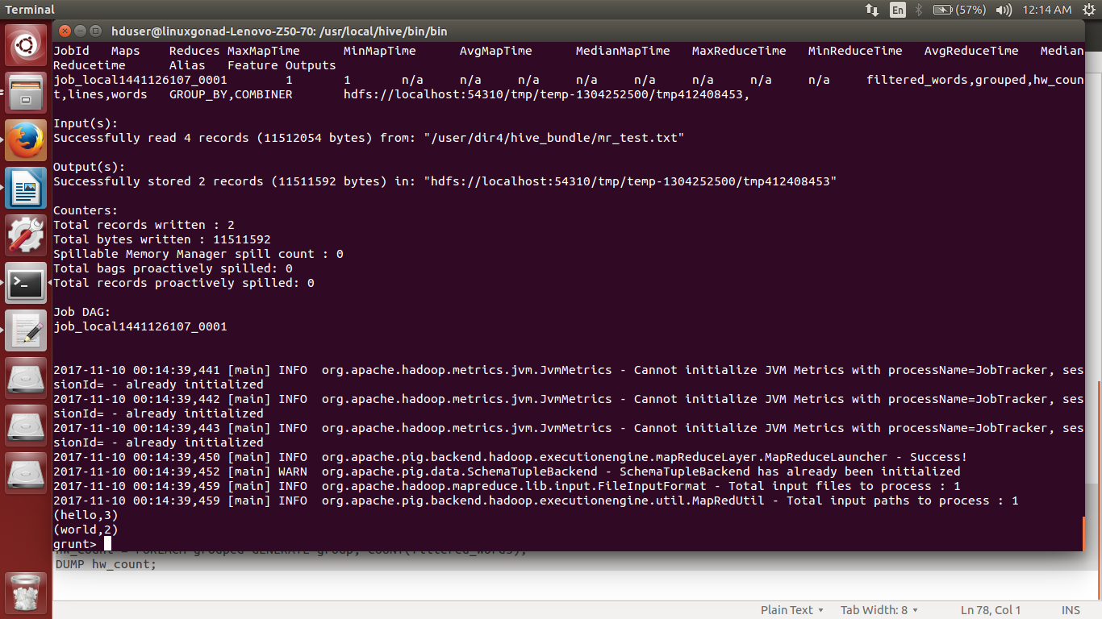

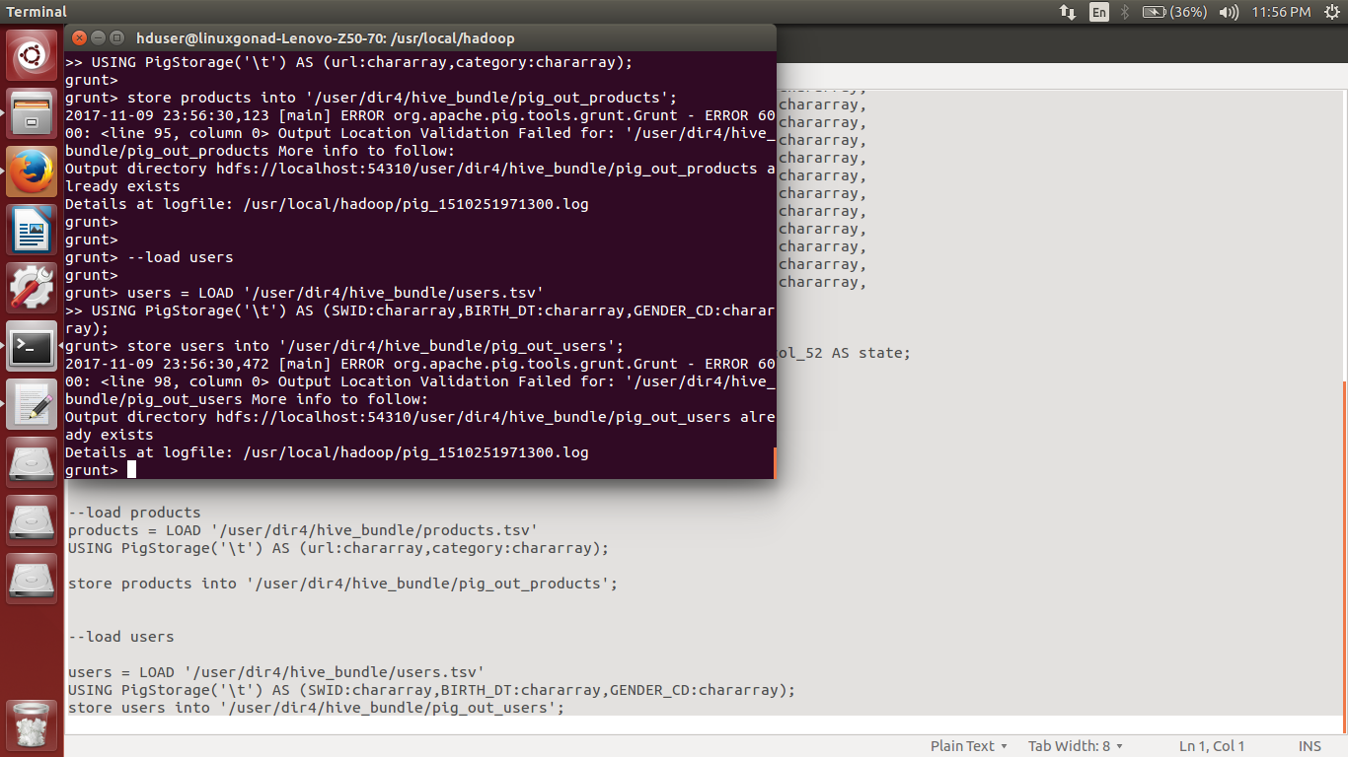Pig Script ran first on the Omniture tsv file

**DATA PIPELINE DESIGN**

Our project is mainly based on Data Pipeline Design.

**Introduction**

A data pipeline is the process of structuring, processing and transforming data in stages regardless of what the source data form may be.

Data pipeline is an automated process that executes at regular interval to ingest, cleanse, transform and aggregates incoming feed of data to generate the output data set in the format that is suitable for downstream processing, with no manual intervention.

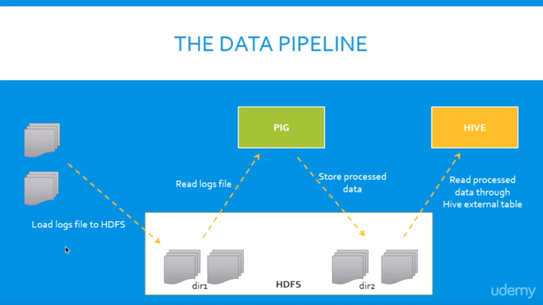

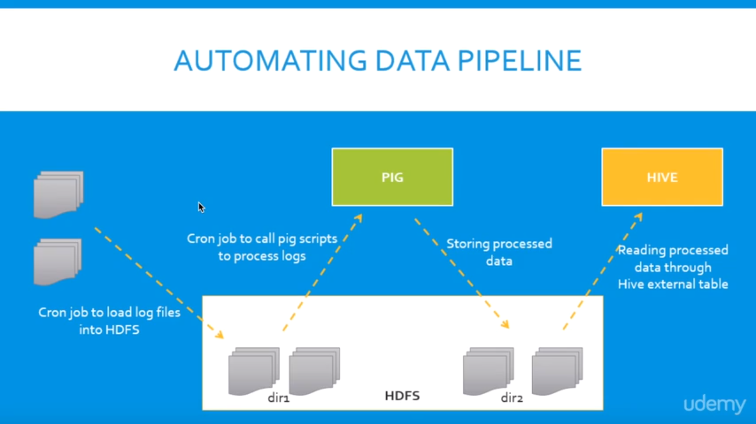

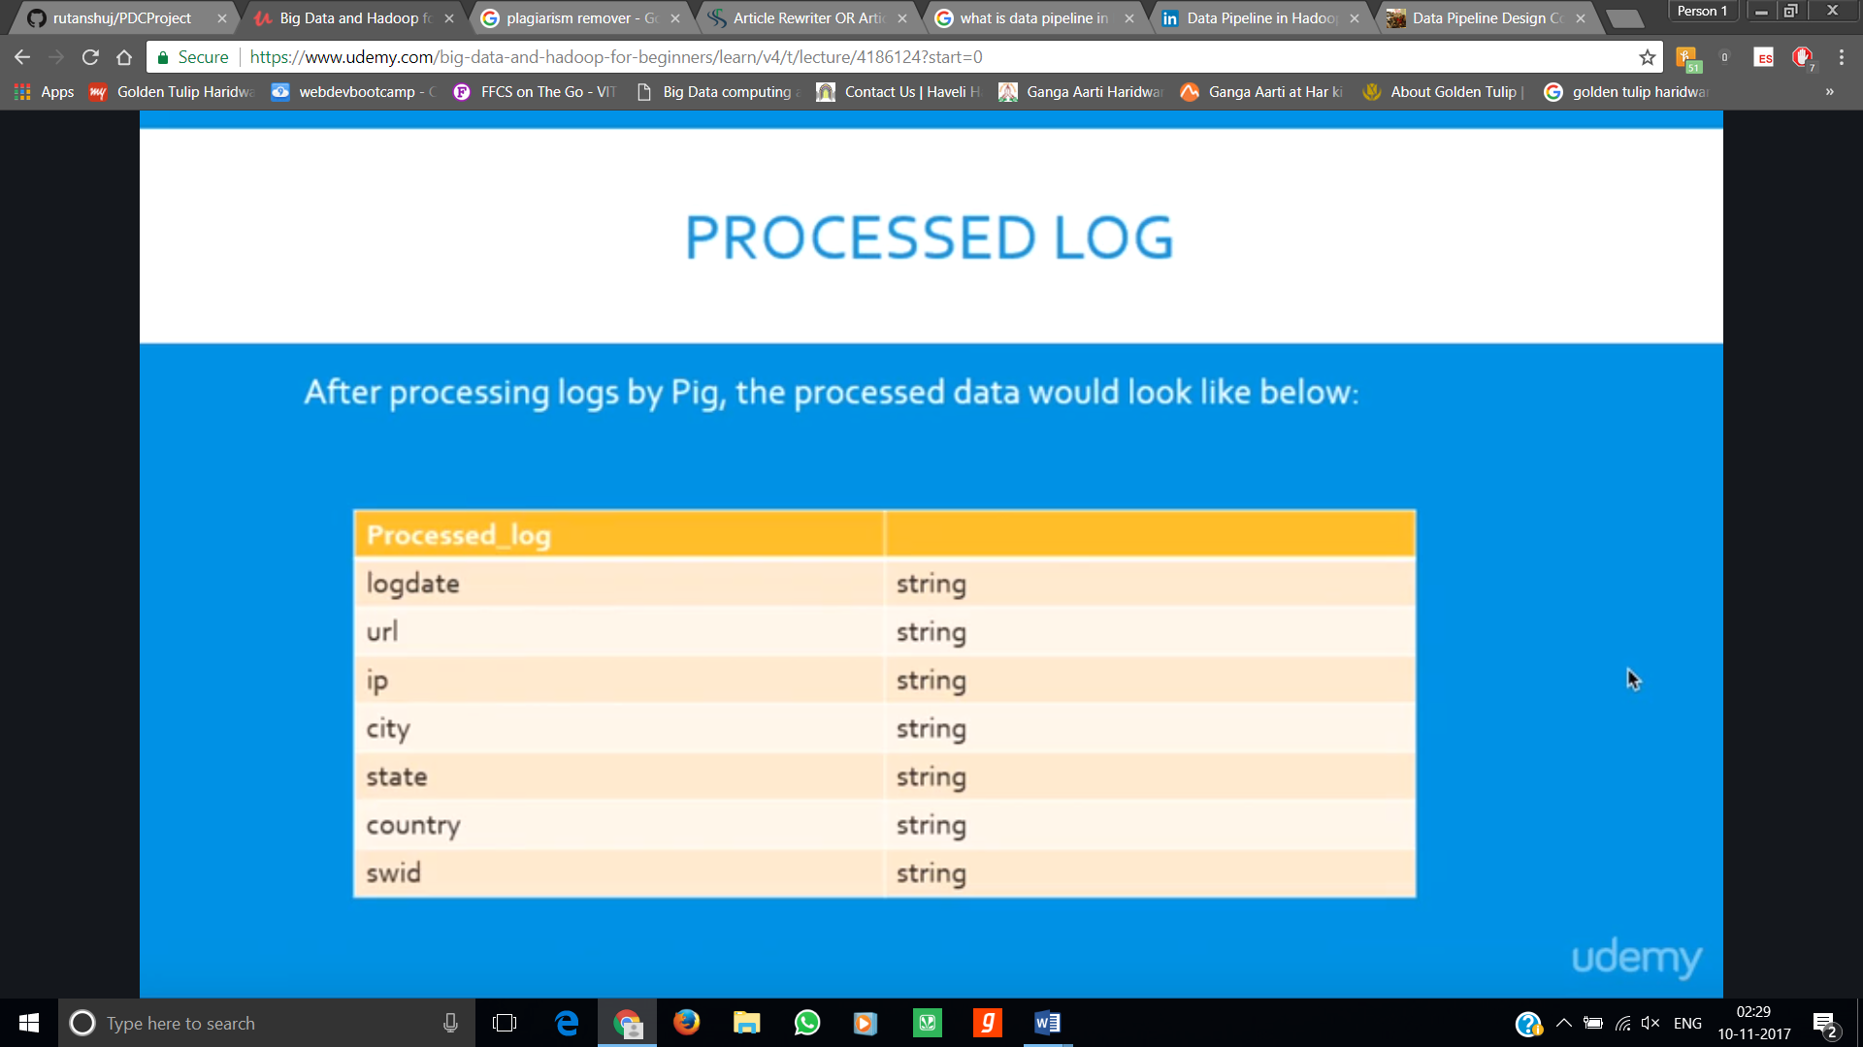

**Implementation is as follows:-**

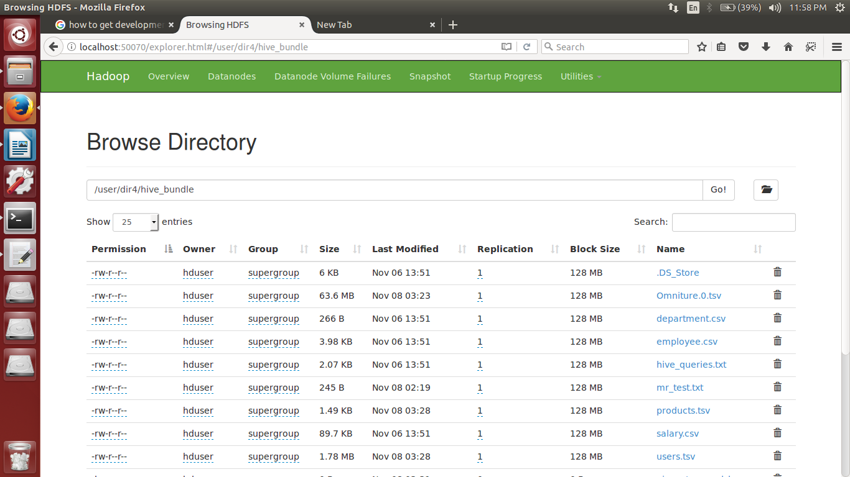Web UI during the pipeline showcasing the logs that are obtained after Pig data extraction

pig_parsed_logs

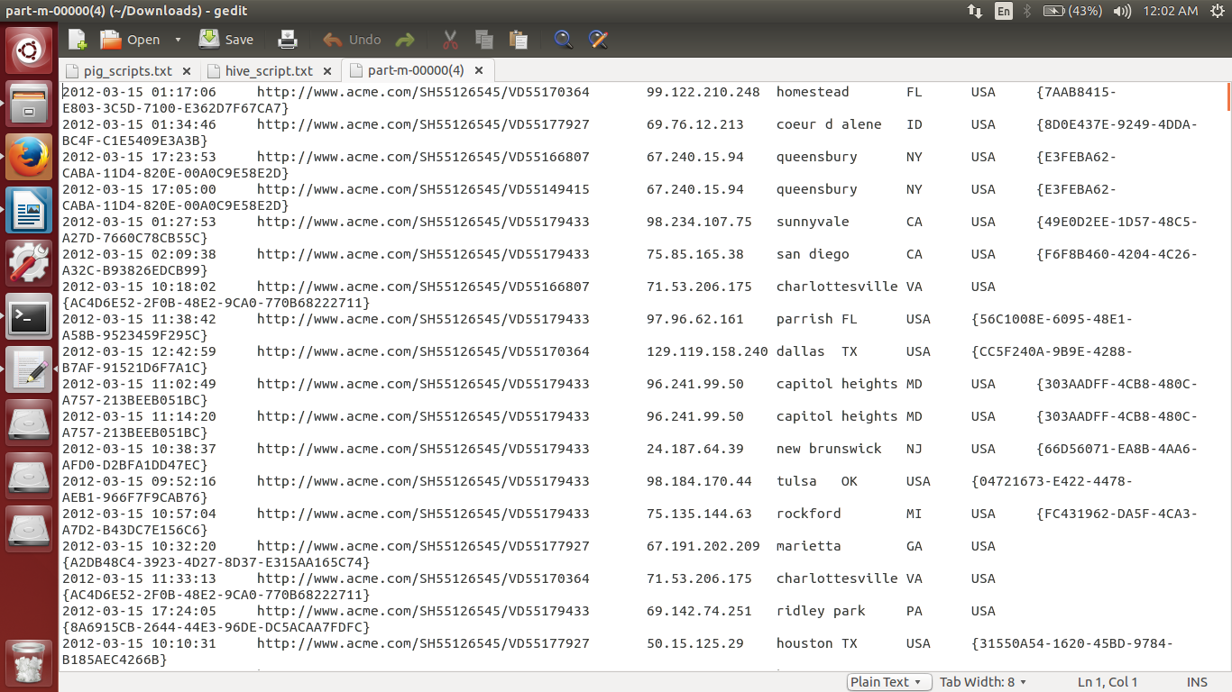

Hive script ran over data stored after pig partitioning

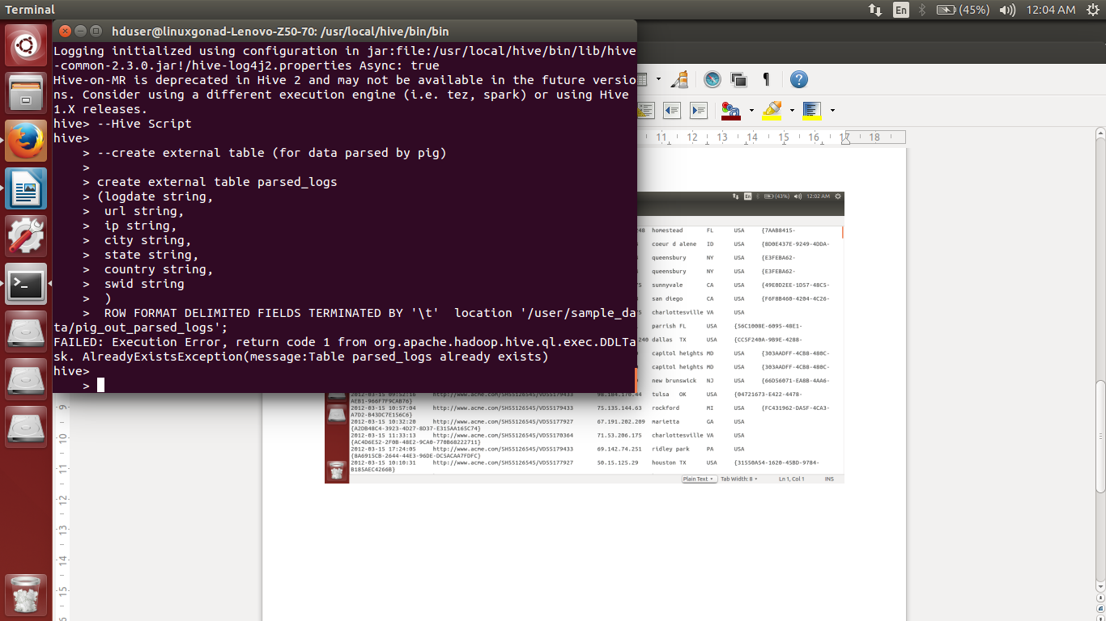

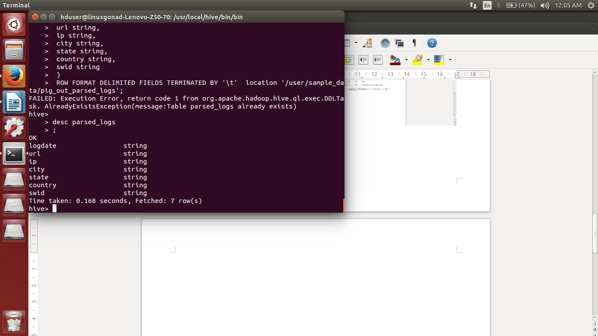desc parsed_logs

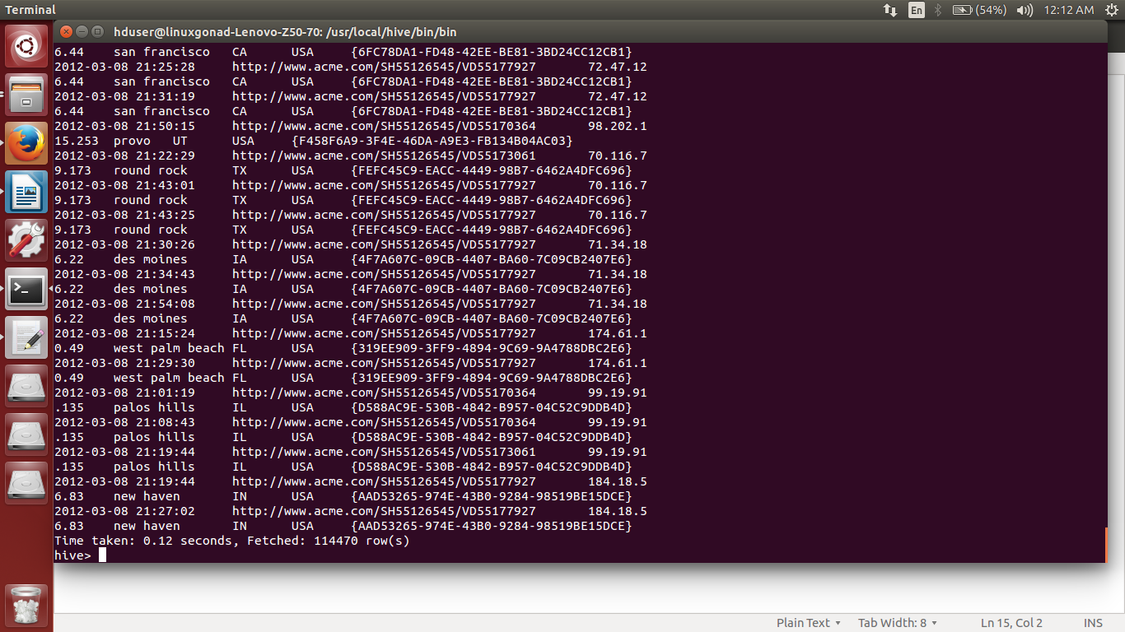Finally end of hive script returning all the records in a structured format along with schema